Z01/Z02/Z03 Ice Maker Serial Communication Protocol V0.0.3

Version Number | Description | Modifier | Revision Date
V0.0.1 | Initial Version | Syx | 2022/5/21
V0.0.2 | Added Version Number Reading | Syx | 2022/6/26
V0.0.3 | 1. Integrated certain customers' customized protocols with the standard protocol into one version.  2. Modified some text content.  3. Added an example for each instruction. | Syx | 2025/2/11

I. Communication Mode

- Serial Port (UART)
- Hardware Physical Port: RS232 or RS485
- 1 start bit, 8 data bits, 1 stop bit, no parity bit, 115200 baud rate
- Data String Format:
"Command Code" + "Length Code" + "Instruction Code" + "Data 1"…+ "Data n" + "Checksum Code" + "End Code"

Command Code | Length Code | Instruction Code | Checksum Code | End Code

- Communication is in the mode of the host querying the slave.
The ice maker motherboard serves as the slave, and the user control device serves as the host. The session process is as shown in the following diagram:
Host
The host sends a query or setting instruction to the slave.
Wait for the slave's response.
Respond according to the host's instruction.
Step 1
Step 2
Slave
Receives the host's instruction.
Receives the slave's response.
Session Flowchart

主机
主机

Note: After the host sends an instruction in Step 1, if it does not receive a response from the slave within 1 second, it will resend. If there is no response after 3 resends, a communication error occurs.

II. Instruction Code

0x55 represents querying slave data.
0xAA represents setting slave data.
The specific data to be queried or set depends on the command code. Please refer to the command code section for details.

III. Length Code

The length code is equal to the sum of the number of all 8 - bit bytes in the data string.
For example:
For "Command Code" + "Length Code" + "Instruction Code" + "Data 1" + "Checksum Code" + "End Code", the length code value is 6.
For "Command Code" + "Length Code" + "Instruction Code" + "Data 1" + "Data 2" + "Checksum Code" + "End Code", the length code value is 7.

IV. Checksum Code

The checksum code value is equal to the lower 8 - bit of the sum of all data except the "Checksum Code" and "End Code".

V. End Code

The end code is fixed as the hexadecimal value "0xFF".
For end code judgment, when "0xFF" is received, query the "Length Code". Combine it with the current number of received bytes. If the number of received bytes is equal to the value of the "Length Code", the reception is complete.

VI. Command Code

Slave Status Query | 0x01
Slave Parameter Query and Setting | 0x02
Power On/Off (Only for Z03) | 0x03
Dispense Beverage | 0x04

Slave Status Query (0x01)

The host queries the slave status: (Host → Slave)

0x01 | Length Code | 0x55 | Checksum Code | End Code

The slave responds to the host: (Host ← Slave)

0x01 | Length Code | 0x55 | Data 1 | Data 2 | (Data 3 only for Motong customers) | Checksum Code | End Code

Data 1
Bit0 | 1: Ice storage bin is full (Note: Ice full is the normal working ice full, not a fault).  0: Normal
Bit1 | 1: Condenser fault  0: Normal
Bit2 | 1: Evaporator fault  0: Normal
Bit3 | 1: Water tank is short of water  0: Normal
Bit4 | 1: Ice - making system is abnormal  0: Normal
Bit5 | 1: Empty the waste water tray  0: Normal
Bit6 | 1: System water inlet is abnormal  0: Normal
Bit7 | 1: Please install the waste water tray  0: Normal

Data 2 | System Working Status
0: Standby state, allowing the APP to send commands for making beverages;
1: Cooking, allowing the APP to send commands for increasing or decreasing the quantity;
2: Shutdown;
3: Please enjoy, no longer allowing the APP to send commands for increasing or decreasing the quantity;
4: Cancelled, the production of this beverage has been cancelled, waiting for the system to return to the standby state;
5: Boot initialization;
6: Fault.

Data 3 | Only for Motong Customers
Bit0 | 1: The ice maker is filling water  0: The ice maker is not filling water
Bit1 | 1: System is short of ice (Note: From the first boot until the ice is full, this bit is always 1; short of ice is not a fault).  0: Normal
Bit2 | Reserved
Bit3 | Reserved
Bit4 | Reserved
Bit5 | Reserved
Bit6 | Reserved
Bit7 | Reserved

Example: The communication screenshot is as follows:
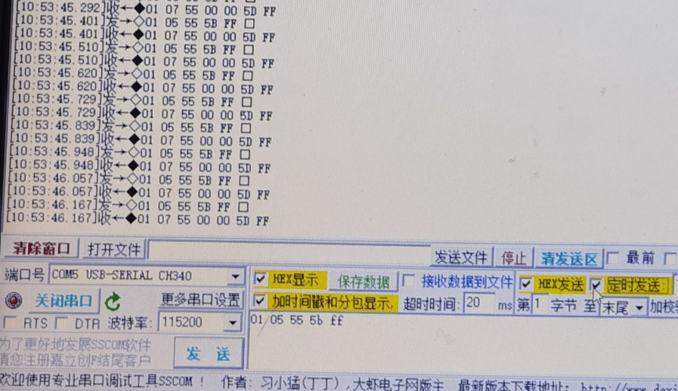

Slave Parameter Query and Setting (0x02)

The host queries the slave parameters: (Host → Slave)

0x02 | Length Code | 0x55 | Checksum Code | End Code

The slave responds to the host: (Host ← Slave)
0x02 | Length Code | 0x55 | Data 1 | Data 2 | Data 3 | Data 4 | Data 5
Data 6 | Data 7 | Data 8 | Data 9 | Data 10 | Data 11 | Data 12 | Data 13
Checksum Code | End Code

Name | Value Range | Value Meaning
Data 1 |  | Condenser temperature, 25 - 60 °C (For example, 400 means 40 °C)
Data 2
Data 3 |  | Evaporator temperature, 1 - (-23) °C (For example, 400 means 400 - 500=-100, - 10 °C)
Data 4
Data 5 |  | Ambient temperature, 0 - 42 °C (For example, 400 means 40 °C)
Data 6
Data 7 | 0 - 3 | Current language, 0 for Chinese, 2 for English, 3 for Japanese
Data 8 | 1 - 120 | Ice quantity
Data 9 | 1 - 10 | Water quantity
Data 10 | 1 - 10 | Ice - water quantity
Data 11 |  | Version number, in ASCII code
Data 12 |  | Version number, in ASCII code
Data 13 |  | Version number, in ASCII code

The host sets the slave parameters: (Host → Slave)
Note: Parameter settings can only be performed when the slave is in a non - fault state.
0x02 | Length Code | 0x55 | Data 1 | Data 2 | Data 3 | Data 4 | Data 5
Data 6 | Data 7 | Data 8 | Data 9 | Data 10 | Checksum Code | End Code

Name | Value Range | Value Meaning
Data 1
Data 2
Data 3
Data 4
Data 5
Data 6
Data 7 | 0 - 3 | Current language, 0 for Chinese, 2 for English, 3 for Japanese
Data 8 | 1 - 120 | Ice quantity
Data 9 | 1 - 10 | Water quantity
Data 10 | 1 - 10 | Ice - water quantity

The slave responds to the host: (Host ← Slave)

0x02 | Length Code | 0xAA | Data 1 | Checksum Code | End Code

Data 1
0x00 | Setting failed
0x01 | Setting successful

Power Off (0x03) Only for Z03

The host sends a power - off instruction to the slave: (Host → Slave)
Note: Power - off can only be performed when the slave is in a non - fault state.

0x03 | Length Code | 0xAA | Checksum Code | End Code

The slave responds to the host: (Host ← Slave)

0x03 | Length Code | 0xAA | Data 1 | Checksum Code | End Code

Data 1
0x00 | Setting failed
0x01 | Setting successful

Dispense Beverage (0x04)

The host sends a dispense - beverage instruction to the slave: (Host → Slave)

0x04 | Length Code | 0xAA | Beverage Number | Data 1 | Checksum Code | End Code

Name | Value Range | Value Meaning
Beverage Number | 1 - 3 | 1 for dispensing ice, 2 for dispensing water, 3 for dispensing ice - water
Data 1 | Ice quantity 1 - 120, water quantity and ice - water quantity 1 - 10 | Ice quantity / water quantity / ice - water quantity. If it is 0, it will be dispensed according to the current stored quantity of the machine

The slave responds to the host: (Host ← Slave)

0x04 | Length Code | 0xAA | Beverage Number | Data 1 | Checksum Code | End Code

Data 1
0x00 | Setting failed
0x01 | Setting successful

Example: Dispense water for 5 seconds: 04 07 aa 02 05 bc ff
Note: In the 100ms version, the above command means dispensing water for 500ms.

